Yiran Fan, John Pak, Gang Ping Zhu

[yfan11@stevens.edu](mailto:yfan11@stevens.edu), [jpak@stevens.edu](mailto:jpak@stevens.edu), [gzhu3@stevens.edu](mailto:gzhu3@stevens.edu)

FE-800-WS

Zhenyu Cui, Khaldoun Khashanah

Model Market Irrationality with Bitcoin and Other Cryptocurrencies

1. Introduction

Cryptocurrencies have become increasingly popular amongst investors and the general public since early 2017.While most people are not able to conceptually understand what cryptocurrencies are and still do not understand how cryptocurrencies operate, one fact that is universally accepted is the significance of cryptocurrencies to the financial market system. To put in layman’s terms, cryptocurrencies can be defined as digital forms of cash stored in a database as various different entries. Within the cryptocurrency realm, the four most recognized cryptocurrencies are Bitcoin (BTC), Litecoin (LTC), Ethereum (ETH), and Ripple (XRP). Compared to its peers, Bitcoin is considered to be the most successful due to the frequent and high volume of trades along with the fact that Bitcoin makes up approximately 40% of the total cryptocurrency market capitalization. Recently, Bitcoin has exhibited signs of extreme volatility with the constant variations and fluctuations in price. Due to the volatility, there is rising concern within the cryptocurrency universe about whether or not Bitcoin is prone to a bubble that will eventually burst.

In the last year, a cryptocurrency named Bitcoin (BTC) hit a high valuation of $19,006 USD before dropping to the its current value of $6,239 USD. All the biggest cryptocurrencies followed the same pattern of growth and descent in the last year due to the public’s opinion of treating these assets as investments. Cryptocurrencies started to rise in popularity due to its design as a decentralized currency that could determine its value based on the market without the interference of central banking systems and government entities. They are digit assets created to serve as a medium of exchange with a high level of anonymity while using strong security to authenticate ownership, volume, and transactions. As its popularity started to rise, cryptocurrencies gained the interests of many individuals looking to reap the returns that were previously reported by other people. With more people jumping into investing in cryptocurrencies, the market value of many cryptocurrencies started to rise due to the hype that was generated by the masses. With the prevalence of cryptocurrencies in the last two years, we will analyze the behavior of these new assets and how they impact the overall financial system. The investment potential and the future of cryptocurrencies are still fairly unknown and while there has been extensive analysis from the community on forecasting cryptocurrencies and advising the public of when to invest and when to sell, the analysis on the nature of cryptocurrencies and their effects on the financial world have not shared the same amount of attention.

The high returns of these assets have created a large opportunity for the creation of new assets within the cryptocurrency world. According to CoinMarketCap, there are a total of 2079 cryptocurrencies in existence.[1] As a result of the large number of cryptocurrencies, we’ll be analyzing a select number of the most valued cryptocurrencies in the market. The cryptocurrencies that we’ll analyze in detail are Bitcoin (BTC), Ethereum (ETH), Ripple (XRP), and Litecoin (LTC). Using these four cryptocurrencies, we’ll explore the behaviors of these digital assets. We’ll initially start by looking at how the stock market is impacted the market volatility of these four cryptocurrencies. Knowing that many individuals started to invest in these assets in the previous year, we can assume that money was invested when there was hype around cryptocurrency and that individuals lost on their expected returns when the price of BTC descended back to the $6,000 USD range and the other cryptocurrencies followed suit with their respective declines. One of our goals is to understand how much of a threat cryptocurrency posed on the stability of the financial market. In order to comprehend this relationship, we sought to analyze the evolutionary dynamics of the cryptocurrency market, which entailed comparing the cryptocurrency market to an ecological system. In essence, the cryptocurrency market mimics a neutral model of evolution, which required the application of the sampling theory and a stochastic process. Based on our analysis, we were able to quantify the birth and death rates of cryptocurrencies, the activity of cryptocurrency (volume of trades), and the distribution of market share. While the dominance of Bitcoin was evident in the early stages of the cryptocurrency era, based on historical data, we were able to see that the market capitalization of Bitcoin has been steadily decreasing while the rest of the cryptocurrencies have been displaying signs of exponential growth.

In additional to the analysis of the impacts to the other markets, we’ll explore the correlation between currency and cryptocurrency. If cryptocurrencies are truly looking to serve as a digit asset to facilitate the transfer of goods and services, they should hold the same principles that currencies adhere to in the modern world. One of those principles is that currency should remain stable from day to day so that the buyer and seller have a mutual understanding of the value being traded. If a currency faces high volatility, we run into the hyperinflation problems that German faced in the First World War with the German mark and that Venezuela is currently facing with the bolivar.

In relation to the stability and volatility of cryptocurrency, we’ll explore the impacts to the behavior of investors when faced with an unfamiliar rate of change. It is difficult to explain the return patterns of Bitcoin with conventional asset pricing models. Behavior finance factors are prime candidates to help explain the return patterns of Bitcoin. For instance, herding behavior suggests that investors gravitate toward the same or similar investments based almost solely on the fact that many others are buying the securities. One the other hand, prospect theory argues that investors value gains and losses differently. In particular, investors are more risk-seeking toward losses. Therefore, it is possible that the abnormal return patterns can be partially contributed irrational behaviors, especially those who are likely to be influenced by others and reluctant to accept losses.

In our exploration of cryptocurrencies, we’ll review the existing research that’s been published to determine what has been investigated and what needs further evaluation. After vetting through the current research, we’ll elaborate on our methodology and findings to further our understanding of cryptocurrency. Based on that understanding, we’ll analyze three points involving the market irrationality with cryptocurrencies: whether the market volatility impact of cryptocurrency impact the financial system, the correlations between currency and cryptocurrency, and measuring cryptocurrency stability and the behaviors of the investors of cryptocurrency.

1. Literature Review

We reviewed a published article on cryptocurrencies and the other aspects of the financial market. As we’re looking to use behavioral finance theories to answer questions related to cryptocurrencies impacts to the stability of the financial system and whether there is a negative correlation between the M1 supply of the world's major currencies such as USD and JPY and the bitcoin volume/value, this review will look into the research others have performed on these new assets/currencies and their impact on the market.

In *Exploring the dynamic relationships between cryptocurrencies and other financial assets* by Corbet, Meegan, Larkin, Lucey, and Yarovaya, the life of the cryptocurrency market is examined along with the events that could have shaped their market value. While examining the timeline of the cryptocurrency market, they looked to achieve three goals in their research: analyze the extent and time variation of cryptocurrency to other financial assets, “estimate unconditional connectedness between markets in time-frequency domain”, and “examine the connectedness between markets” across short, medium, and long durations.[2]

Leveraging a vector autoregression (VAR), the team looked at the spillover and effects of changes in prices between different financial assets. To measure the spillover and effects between the different markets, they created indexes between two markets that they wanted to compare. There was a Directional Spillover Index created to estimate the direction and reverse direction spillover indexes from one market to another. In addition, a Net Spillover Index was calculated as “the difference between the total shocks transmitted from one market to all markets” another along with a reverse direction of that difference.[3] These two indexes along with a Total Spillover Index, calculated from the total volatility contributions, visualize the effects of spillover across cryptocurrencies and other financial markets.

Through a generalized autoregressive conditional heteroskedasticity (MVGARCH), Corbet, Meegan, Larkin, Lucey, and Yarovaya examine the volatility clustering of select cryptocurrencies. To frame this analysis, the authors look at a few key structural events and the volatility in the context of those events. From inception of cryptocurrency to the present, they looked at key occurrences around the globe such as the shutdown of the second version of the Silk Road on the dark web in 2014, the Bitcoin flash crash in 2015, the Brexit referendum in 2016, and the introduction of Ripple (XRP) in 2017. By looking at the relationships between cryptocurrencies and other financial assets, they determine that the volatility of the returns from cryptocurrencies are not constant over time. This indicates that the cryptocurrency world could be enclosed in their own market or environment of stability and volatility whereas events that affect the users of cryptocurrency are the leading factors of volatility.

As “the values for directional return and volatility from VIX, Bond, Gold, FX, SP500 and GSCI to cryptocurrency markets are very low”, the authors indicate that the effects of the other financial markets are not as critical to the dynamics of the cryptocurrency.[4] Their analysis with the relationship between cryptocurrencies and other markets along with results from their volatility analysis reveal that the selected cryptocurrencies being researched are rather isolated from the other markets. While isolated from other financial assets, their research showed that the major cryptocurrencies are interconnected and their returns impact each other’s performance.

Various studies have examined how behavior finance factors such as herding behaviors and prospect theory link to Cryptocurrencies returns. In *Prospect Theory and Stock Returns: An Empirical* Test, Barberis, Mukherjee & Wang (2014) examined cross-section stock returns of US market and found out that investors are heavily influenced by past stock return distribution and believes future performance will converge to historical trend. They are reluctant to dispose cryptocurrencies during downtrend and take losses since they believe prices will bounce back in the future. Similarly, Zhang & Semmler (2009) in *Prospect theory for stock markets: Empirical Evidence with Time-Series Data* argued that investors view past gains and losses differently and are more risk-taking during periods of losses. In *Herding in the cryptocurrency market: CSSD and CSAD approache.*, Vidal-Tomás, Ibáñez & Farinós (2018) found out that herding behaviors exist during the extreme lower tail of returns and smaller cryptocurrencies are herding with the major ones. Therefore, investors make decision largely based on the performance of the major cryptocurrencies.

1. Methodology & Results

For our research, we’ll start by gathering our data, cleaning the data, and running exploratory analysis on our data. After the exploratory analysis, we’ll measure volatility and create models to determine a proper fit of the data that we’re looking at. To facilitate further analysis, we’ll also need to create proper definitions of how a currency should behave. After classifying what defines a currency, we’ll fit that information against our cryptocurrency trends to determine if any cryptocurrency should be classified as a currency and whether any of the cryptocurrencies look like they’ll form to the behaviors of a real currency.

We started by gathering data regarding cryptocurrencies from CoinMarketCap and exchange rate data from Kaggle. After cleaning the data, we initially explored the trends of the most valued cryptocurrency, BTC, across different timelines. Our analysis can be visualized in Figure 1 where we start to see the same year over year trends in the more recent years. As we progress forward with the exploration of our data, we’re continuing to look for trends and anomalies in our data. As mentioned previously, we’ll primarily look at Bitcoin (BTC), Ethereum (ETH), Ripple (XRP), and Litecoin (LTC) for our analysis. With our plot pairwise relationship across the four cryptocurrencies, we see that they share the same movement across their high, close, volume, and market cap values. This is shown within Figure 2.

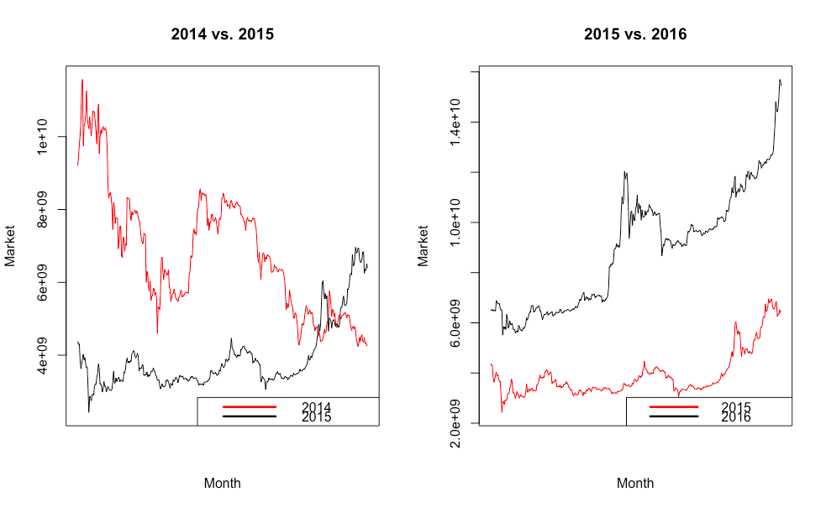

**Figure 1: Comparison of Market of Bitcoin**

A close up of a map

Description generated with high confidence

**Figure 2: Plot pairwise relationships (BTC, ETH, XRP, LTC)**

As we dived deeper into the relationships of cryptocurrencies, we looked at the life cycle of our modern currencies. We calculated the volatility for each currency by using a logarithmic return and the standard deviation of it. In graphing the volatility and US exchange rate of the UK Pound and Australian Dollar, we see that there is not a large volatility with our currencies. There is a slight jump in volatility in the UK Pound chart as there were certain data points that were missing in the data set. The data regarding the UK Pound and the Australian dollar can be viewed in Figure 3. Comparing these charts to the charts of the volatility in cryptocurrencies, we see a significant difference. The cryptocurrencies that we’re analyzing have volatility throughout their life. Aside from ETH, the other three cryptocurrencies went through a period of high volatility early on, which gradually decreased before increasing drastically in the last year. ETH, on the other hand, shows a trend towards a lower volatility with the recent past year of activity. This comparison of cryptocurrencies is shown in Figure 4 - 7.

A screenshot of a cell phone

Description generated with high confidence A picture containing text, map

Description generated with very high confidence

**Figure 3: GBP & AUD Exchange Rate and Volatility**

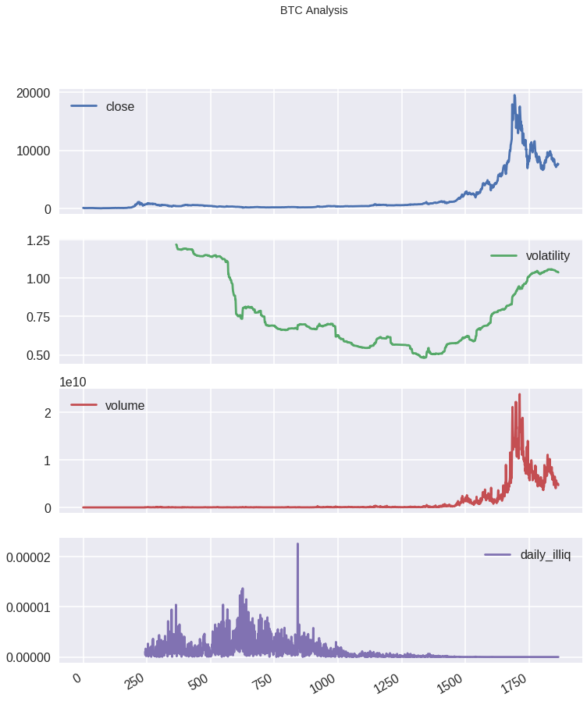

**Figure 4: BTC XRP High, Volatility, and Volume**

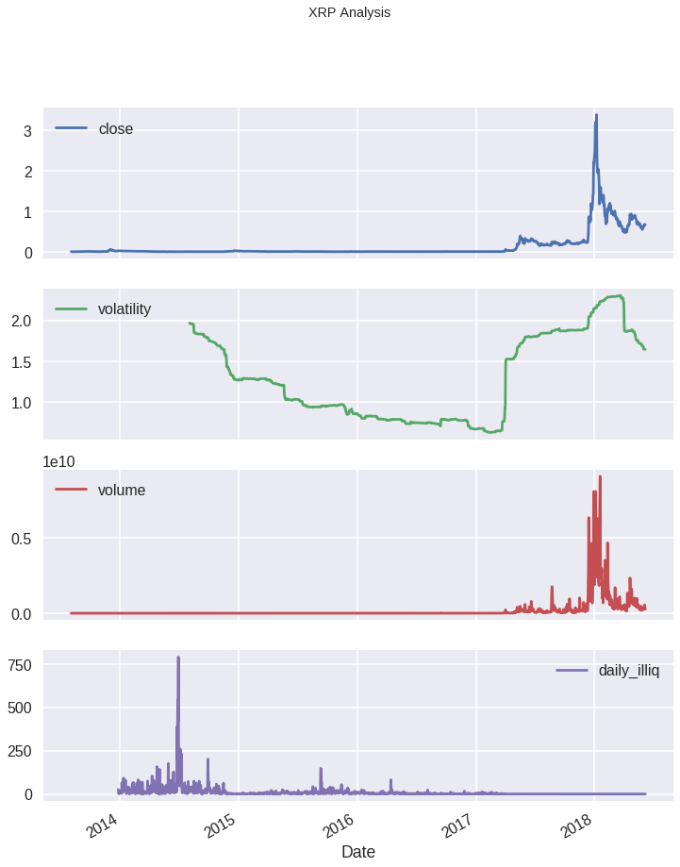

**Figure 5: XRP High, Volatility, and Volume**

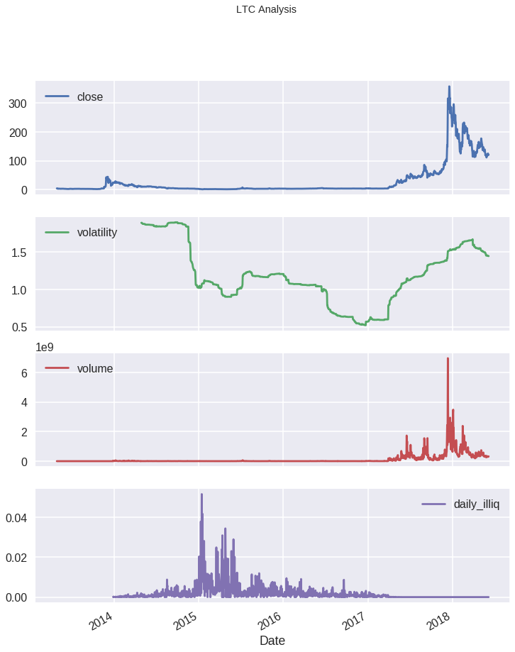

**Figure 6: LTC High, Volatility, and Volume**

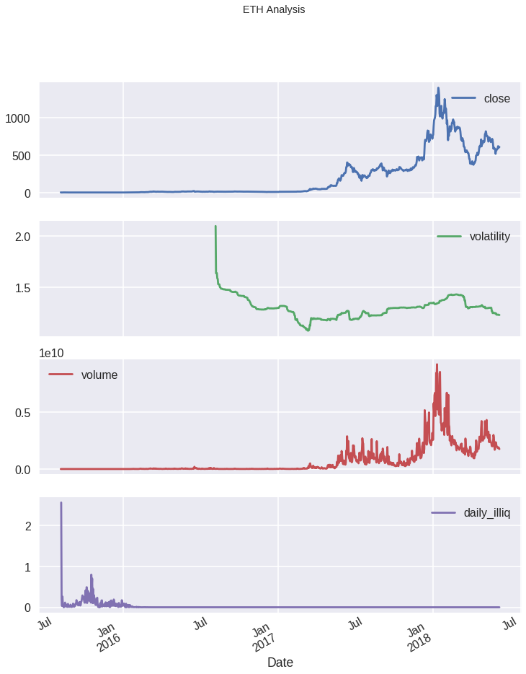

**Figure 7: ETH High, Volatility, and Volume**

As we begin our ARMA model fitting, we’ll check the stationarity of price of these four cryptocurrencies with augmented Dickey–Fuller (ADF) test. Bitcoin, Ethereum, and Litecoin all display non-stationarity, which is the same as expectation. However, price of XRR seems stationary according to augmented ADF test. Current researches and practices suggest that returns are most likely stationary compared to raw prices. In fact, all models learned in class are fitted on data of returns rather than prices. To eliminate non-stationarity, we use returns of these four cryptocurrencies to fit time-series models. Not surprisingly, augmented ADF test shows that returns of all four cryptocurrencies are stationary.

Time series model extracts and analyzes meaningful statistics and characteristic of time-series data such as price returns. The time-series model selected in this report is autoregressive–moving-average (ARMA) model. ARMA contains both an autoregressive factor and a moving average factor. It is a combination of autoregressive model and moving-average model. Specifically, we select an ARMA(2,2) model, which has two autoregressive terms and two moving-average terms.

First, we will explore the fitting of ARMA on Bitcoin. The following table presents the results of ARMA fitting.

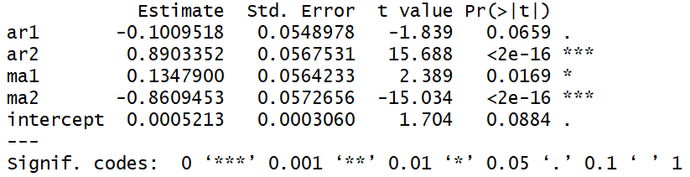

**Figure 8: ARMA(2,2) of Bitcoin Returns**

The results suggest all factors are significant. This suggests that Bitcoin is strongly correlated to its lag variables and moving-average terms. The coefficients on all four factors are also reasonable. We want to determine if the best results are from ARMA model or ARIMA. To compare between different models, we use log likelihood as benchmarks. The ARMA(2,2) model has likelihood of 4288.42. If an ARIMA(p, d, q) has better log likelihood, then it is a better model.

The algorithm used in parameter selection is Hyndman-Khandakar algorithm (Hyndman & Khandakar, 2008). Based on the algorithm, the best ARIMA model for Bitcoin is ARIMA(3 ,0, 3). The new log likelihood is 4302.85. However, Ljung-Box test suggests that residuals are not independent and there exists autocorrelation among the residuals. As a result, ARIMA model may not be a good fit to the data. The specific characteristics of residuals for Bitcoin is displayed below.

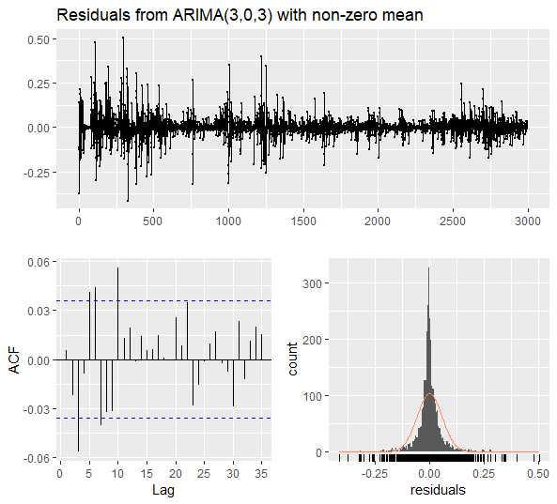

**Figure 9: Residuals from ARMIA(3, 0, 3) with non-zero mean**

We applied Hyndman-Khandakar algorithm to other three cryptocurrencies. The results are reported in the following bullet points:

* The best model for Ethereum is ARIMA(0, 0, 2). Ljung-Box test suggests that residuals are independent. However, the model appears to be a poor fit overall.
* The best model for Litecoin is ARIMA(0, 0, 1). However, similar to Bitcoin, Ljung-Box test suggests that residuals are not independent.
* The best model for XRP is ARIMA(1, 0, 1). Ljung-Box test suggests residuals are independent. In addition, model appears to be a good fit overall. The forecasted returns based on the model is displayed below.

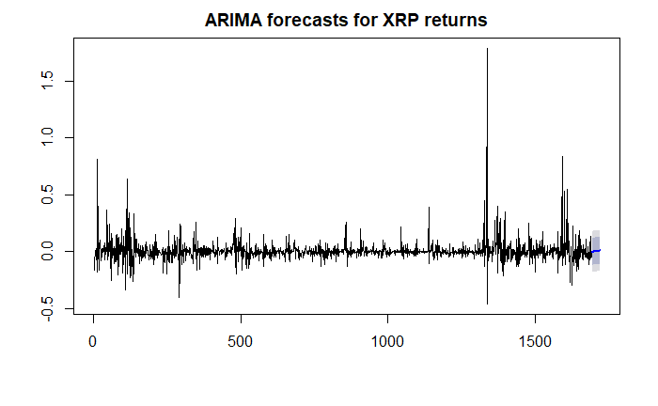

**Figure 10: ARIMA forecasts for XRP returns**

Therefore, the results suggest that ARIMA, or ARMA, may not be the best model for the selected cryptocurrencies. ARIMA seems to be a good fit only for XRP.

Continuing our analysis, we consider the fitting of ARMA on Ethereum data. The table below shows the results of ARMA(2,2) on Ethereum.

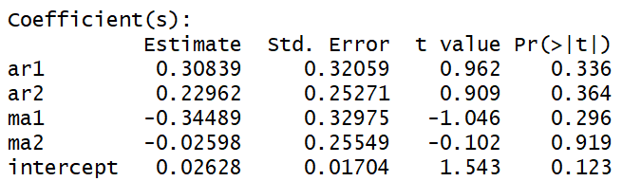

**Figure 11: ARMA(2,2) of Ethereum Returns**

Interestingly, none of the autoregressive nor moving-average terms are significant. The p-values are far too large to reject the null hypothesis. This seems to suggest that Ethereum are not correlated with its lag variables and moving-average terms.

Next, we will analyze ARMA fitting on Litecoin. The table below presents the results of model fitting.

**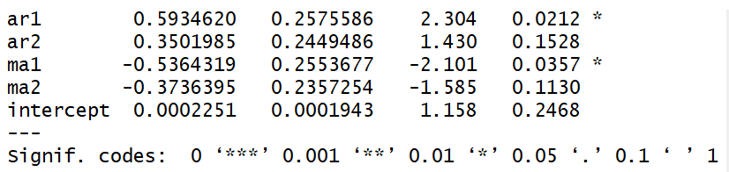  
Exhibit 12: ARMA(2,2) of Litecoin Returns**

Litecoin seems to be between Bitcoin and Ethereum. Only AR(1) and MA(1) terms are significant at 10%, although AR(2) and MA(2) are close enough. Therefore, Litecoin returns are correlated with past returns and moving averages.

Lastly, we will fit XRP with an ARMA(2,2) model. The table below presents the results.

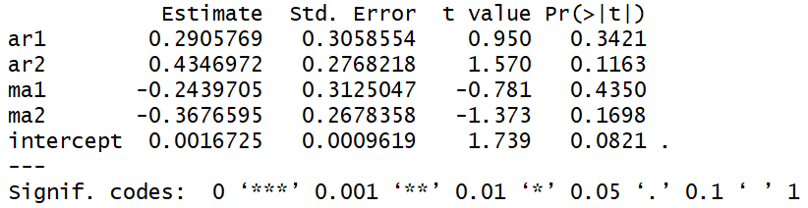

**Exhibit 13: ARMA(2,2) of Litecoin Returns**

The results are also interesting. P-values suggests that AR(2) and MA(2) are more significant than AR(1) and MA(1). It is difficult to explain the reasons for these results. Recall earlier that prices of XRP seems stationary under augmented ADF tests. The ARMA(2,2) model fits well in Bitcoin and Litecoin. However, it fails to explain returns of Ethanium and XRP. Some possible explanations for these results are seasonality and large noises.

We continue to explore other time series models with GARCH. One of the major assumptions for ARIMA is homoskedasticity. GARCH, short for generalized autoregressive conditional heteroskedasticity, takes heteroskedasticity into account. For simplicity purpose, we will create a univariate case and order (1, 1) for GARCH fitting. Results of GARCH fitting on Bitcoin is displayed below. For this part, conditional mean is species as (1, 1) The results are displayed below.

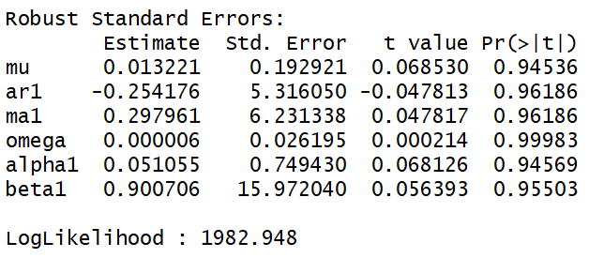

**Exhibit 14: GARCH fitting of BTC**

Based on the results, GARCH seems to be a better fit than ARMA and ARIMA alone due to its higher loglikelihood and lower AIC. Therefore, GARCH is a better fit on ARIMA for Bitcoin.

GARCH model fit on Ethereum has higher AIC and lower log likelihood than GARCH. Therefore, ARIMA is better fit for Ethereum. Parameters for GARCH on Ethereum is listed below.

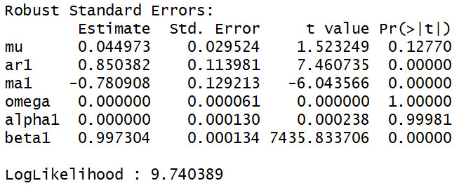

**Exhibit 15: GARCH fitting of ETH**

Litecoin results are similar to Ethereum. ARIMA is the better model for Litecoin than GARCH.

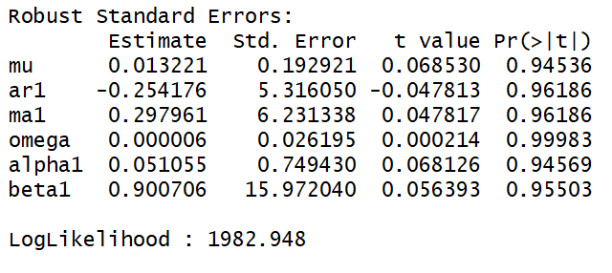

**Exhibit 16: GARCH fitting of LTC**

Lastly, we fit XRP with GARCH. For XRP, GARCH is the better fit due to higher log likelihood and lower AIC. Parameters fitting results are listed below.

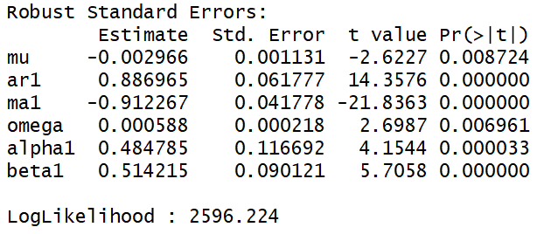

**Exhibit 17: GARCH fitting of XRP**

We take an overall comparison of ARIMA and GARCH along with their fittings results in the table below for our four cryptocurrencies.

|  |  |  |  |  |
| --- | --- | --- | --- | --- |
| Log Likelihood | | | | |
|  | BTC | ETH | LTC | XRP |
| ARIMA | 4302.85 | 9.57 | 2334.6 | 1879.6 |
| GARCH | 5148.935 | 8.258826 | 1982.948 | 2596.224 |
| AIC | | | | |
|  | BTC | ETH | LTC | XRP |
| ARIMA | -8589.7 | -11.4 | -4663.2 | -3751.2 |
| GARCH | -10293.9 | -7.48078 | -3953.89 | -5180.43 |

**Exhibit 18: Comparison of ARIMA and GARCH**

Overall, GARCH is better for Bitcoin and XRP and ARIMA is better for Ethereum and Litecoin. However, as mentioned before, ARIMA model needs homoscedasticity, which is not present in Bitcoin and Litecoin.

Our more detailed cryptocurrency market analysis required a relatively short timeframe of roughly 845 days or specifically from January 1, 2016 to April 24, 2018. Although cryptocurrencies are not relatively new per se, this timeframe was chosen based on the market’s sentiment and view that cryptocurrencies were on the rise in the beginning of 2016 and picked up relatively rapidly approaching the end of 2017 to early 2018. Based on this timeframe, we designated the top 25 cryptocurrencies to be the ones with the greatest market capitalization.

**Top 25 Cryptocurrencies Based on Market Capitalization  
 From January 1, 2016 to April 24, 2018**

|  |  |  |  |  |
| --- | --- | --- | --- | --- |
| **1** | **2** | **3** | **4** | **5** |
| BTC | ETH | XRP | BCH | ADA |
| 6 | 7 | 8 | 9 | 10 |
|  |  |  |  |  |
| **LTC** | **XEM** | **LXM** | **MIOTA** | **TRX** |
| 11 | 12 | 13 | 14 | 15 |
| NEO | DASH | EOS | BTG | XMR |
| **16** | **17** | **18** | **19** | **20** |
| QTUM | ICX | NANO | ETC | LSK |
| **21** | **22** | **23** | **24** | **25** |
| XVG | VEN | SC | BCN | BCC |

**Figure 19: Top 25 Cryptocurrencies Based on Market Capitalization**

**Statistics of Price of Top 25 Cryptocurrencies   
From January 1, 2016 to April 24, 2018**

|  |  |  |  |  |  |
| --- | --- | --- | --- | --- | --- |
|  | BTC | ETH | XRP | BCH | ADA |
| Mean | 3322.226615 | 207.138636 | 0.237533 | 1076.572862 | 0.275906 |
| Max | 19497.400000 | 1396.420000 | 3.380000 | 3923.070000 | 1.110000 |
| Min | 364.330000 | 0.937124 | 0.005112 | 213.150000 | 0.018539 |
| SD | 4169.488712 | 294.700492 | 0.454351 | 730.053414 | 0.253838 |
| Skewness | 1.683480 | 1.683228 | 3.316079 | 1.176001 | 1.137998 |
| Kurtosis | 5.089514 | 5.226794 | 16.726035 | 4.000751 | 3.802793 |

**Figure 20: Statistics of Price of Top 1-5 Cryptocurrencies**

|  |  |  |  |  |  |
| --- | --- | --- | --- | --- | --- |
|  | LTC | XEM | XLM | MIOTA | TRX |
| Mean | 47.222142 | 0.161767 | 0.067835 | 1.382138 | 0.033170 |
| Max | 358.340000 | 1.840000 | 0.896227 | 5.370000 | 0.220555 |
| Min | 3.000000 | 0.000162 | 0.001444 | 0.158688 | 0.001427 |
| SD | 71.879257 | 0.281477 | 0.143538 | 1.212309 | 0.036243 |
| Skewness | 1.938002 | 2.934472 | 2.586661 | 1.311837 | 2.165497 |
| Kurtosis | 6.059990 | 13.065136 | 9.354333 | 3.769603 | 10.273579 |

**Figure 21: Statistics of Price of Top 6-10 Cryptocurrencies**

|  |  |  |  |  |  |
| --- | --- | --- | --- | --- | --- |
|  | NEO | DASH | EOS | BTG | XMR |
| Mean | 28.656651 | 193.322817 | 4.887134 | 51.587933 | 71.437865 |
| Max | 187.410000 | 1550.850000 | 16.230000 | 500.130000 | 469.200000 |
| Min | 0.080181 | 3.030000 | 0.493225 | 0.026703 | 0.428456 |
| SD | 40.679927 | 284.344041 | 4.201161 | 94.061054 | 107.714822 |
| Skewness | 1.559278 | 1.940776 | 0.668560 | 2.049701 | 1.738705 |
| Kurtosis | 4.538639 | 6.559614 | 2.228318 | 6.431769 | 4.959180 |

**Figure 22: Statistics of Price of Top 11-15 Cryptocurrencies**

|  |  |  |  |  |  |
| --- | --- | --- | --- | --- | --- |
|  | QTUM | ICX | NANO | ETC | LSK |
| Mean | 19.320833 | 3.753687 | 3.992687 | 11.690248 | 4.710496 |
| Max | 94.670000 | 12.190000 | 33.700000 | 44.050000 | 34.110000 |
| Min | 3.880000 | 0.455864 | 0.007292 | 0.602402 | 0.104780 |
| SD | 15.131308 | 2.648051 | 6.889332 | 11.096228 | 7.348239 |
| Skewness | 1.935382 | 1.140434 | 2.014060 | 0.816312 | 1.970450 |
| Kurtosis | 6.667972 | 3.491044 | 6.818243 | 2.722665 | 6.088526 |

**Figure 23: Statistics of Price of Top 16-20 Cryptocurrencies**

|  |  |  |  |  |  |
| --- | --- | --- | --- | --- | --- |
|  | XVG | VEN | SC | BCN | BCC |
| Mean | 0.014031 | 2.295594 | 0.006359 | 0.001281 | 91.651573 |
| Max | 0.255441 | 8.270000 | 0.094008 | 0.016694 | 463.310000 |
| Min | 0.000008 | 0.048002 | 0.000017 | 0.000026 | 0.128067 |
| SD | 0.035106 | 2.286914 | 0.011619 | 0.002120 | 122.603880 |
| Skewness | 3.348864 | 0.649814 | 3.436139 | 2.810621 | 1.377449 |
| Kurtosis | 15.258572 | 2.170094 | 18.564436 | 13.947567 | 3.754165 |

**Figure 24: Statistics of Price of Top 21-25 Cryptocurrencies**

We observed various statistical properties of the price of the top 25 cryptocurrencies from January 1, 2016 to April 24, 2018 such as the mean, maximum, minimum, standard deviation, skewness, and kurtosis. The closing price for each of the cryptocurrencies was designated as our price every day from January 1, 2016 to April 24, 2018.

Using the top 25 cryptocurrencies from January 1, 2016 to April 24, 2018, we observed similar statistical properties (excluded the maximum and minimum) of the price as mentioned previously from January 1, 2014 to December 31, 2015.

**Statistics of Price of Top 25 Cryptocurrencies   
From January 1, 2014 to December 31, 2015**

|  |  |  |  |  |  |
| --- | --- | --- | --- | --- | --- |
|  | BTC | ETH | XRP | BCH | ADA |
| Mean | 399.844959 | 0.942803 | 0.009214 | N/A | N/A |
| SD | 170.412460 | 0.298068 | 0.005425 | N/A | N/A |
| Skewness | 0.962436 | 2.025782 | 1.379145 | N/A | N/A |
| Kurtosis | 3.161077 | 12.049649 | 4.229792 | N/A | N/A |

**Figure 25: Statistics of Price of Top 1-5 Cryptocurrencies**

|  |  |  |  |  |  |
| --- | --- | --- | --- | --- | --- |
|  | LTC | XEM | XLM | MIOTA | TRX |
| Mean | 6.269877 | 0.000143 | 0.002775 | N/A | N/A |
| SD | 5.752484 | 0.000035 | 0.000947 | N/A | N/A |
| Skewness | 1.723164 | 1.375504 | 1.454210 | N/A | N/A |
| Kurtosis | 5.425155 | 7.404738 | 5.100803 | N/A | N/A |

**Figure 26: Statistics of Price of Top 6-10 Cryptocurrencies**

|  |  |  |  |  |  |
| --- | --- | --- | --- | --- | --- |
|  | NEO | DASH | EOS | BTG | XMR |
| Mean | N/A | 3.189907 | N/A | N/A | 0.895744 |
| SD | N/A | 2.316608 | N/A | N/A | 0.777428 |
| Skewness | N/A | 2.331209 | N/A | N/A | 1.909400 |
| Kurtosis | N/A | 8.978561 | N/A | N/A | 6.523318 |

**Figure 27: Statistics of Price of Top 11-15 Cryptocurrencies**

|  |  |  |  |  |  |
| --- | --- | --- | --- | --- | --- |
|  | QTUM | ICX | NANO | ETC | LSK |
| Mean | N/A | N/A | N/A | N/A | N/A |
| SD | N/A | N/A | N/A | N/A | N/A |
| Skewness | N/A | N/A | N/A | N/A | N/A |
| Kurtosis | N/A | N/A | N/A | N/A | N/A |

**Figure 28: Statistics of Price of Top 16-20 Cryptocurrencies**

|  |  |  |  |  |  |
| --- | --- | --- | --- | --- | --- |
|  | XVG | VEN | SC | BCN | BCC |
| Mean | 0.000012 | N/A | 0.000029 | 0.000027 | N/A |
| SD | 0.000006 | N/A | 0.000010 | 0.000018 | N/A |
| Skewness | 0.074060 | N/A | 1.143326 | 1.208187 | N/A |
| Kurtosis | 2.960693 | N/A | 6.351550 | 3.898623 | N/A |

**Figure 29: Statistics of Price of Top 21-25 Cryptocurrencies**

Based on the above Figures 23-27, we recognize that many of the cryptocurrencies have no statistical properties available. 14 out of the top 25 cryptocurrencies from January 1, 2016 to April 24, 2018 did not exist in this previous era. Within a span of roughly two and a half years, we recognize that 14 of the top 25 cryptocurrencies are relatively new. While Bitcoin always remains at the top in terms of market capitalization, we are able to observe that there is much growth amongst the cryptocurrencies, along with plenty of births and deaths of cryptocurrencies. A large positive skewness, which essentially is a skewness greater than 1, implies that the mean falls above the median and a high kurtosis, which essentially is a kurtosis greater than 3, implies that there are a higher number of fat tails. Based on the above data, we are able to deduce that most, if not all the top 25 cryptocurrencies exhibit large positive skewness along with a high kurtosis.

A popular controversy within the cryptocurrency universe is whether cryptocurrencies are investments or forms of currency. In order to differentiate between an investment and a currency, we aimed to establish criteria for the judgment of cryptocurrencies. The various metrics that cryptocurrencies are currently characterized by are price, market share, market capitalization, rank, volume, age, and return on investment (ROI). Out of these metrics, the ROI, price, and volume are the most important measurements used to classify a cryptocurrency as an investment versus a currency.

**Statistics of % Change in ROI and Volume of Top 25 Cryptocurrencies   
From January 1, 2016 to April 24, 2018**

|  |  |  |  |  |  |
| --- | --- | --- | --- | --- | --- |
|  | BTC | ETH | XRP | BCH | ADA |
| Mean ROI | 0.458373 | 1.026528 | 0.997051 | 1.074213 | 2.205112 |
| Max ROI | 25.247175 | 35.360360 | 179.366892 | 53.969127 | 136.680964 |
| Min ROI | -18.741098 | -27.055306 | -46.004676 | -35.984068 | -25.075160 |
| Mean Volume | 6.741553 | 15.674178 | 25.435248 | 43.357505 | 21.637806 |
| Max Volume | 248.957231 | 494.628713 | 1846.241466 | 6033.016097 | 505.426477 |
| Min Volume | -74.727698 | -71.478270 | -86.662184 | -71.031277 | -74.491297 |

**Figure 30: Statistics of % Change in ROI and Volume of Top 1-5 Cryptocurrencies**

|  |  |  |  |  |  |
| --- | --- | --- | --- | --- | --- |
|  | LTC | XEM | XLM | MIOTA | TRX |
| Mean ROI | 0.660399 | 1.444348 | 1.132198 | 0.957198 | 3.121073 |
| Max ROI | 66.587112 | 170.628441 | 106.071964 | 46.808511 | 119.606559 |
| Min ROI | -32.642151 | -30.333459 | -30.674524 | -31.411531 | -31.761872 |
| Mean Volume | 15.455644 | 30.107298 | 44.264635 | 14.972987 | 21.028272 |
| Max Volume | 2155.329035 | 1731.806696 | 4723.553277 | 409.889719 | 1119.143764 |
| Min Volume | -72.921972 | -80.723528 | -89.354713 | -73.912258 | -62.938636 |

**Figure 31: Statistics of % Change in ROI and Volume of Top 6-10 Cryptocurrencies**

|  |  |  |  |  |  |
| --- | --- | --- | --- | --- | --- |
|  | NEO | DASH | EOS | BTG | XMR |
| Mean ROI | 1.556743 | 0.811884 | 1.726412 | 4.703933 | 1.073804 |
| Max ROI | 122.813688 | 54.921112 | 168.316832 | 681.129272 | 79.433962 |
| Min ROI | -40.698947 | -21.590494 | -31.957920 | -99.836299 | -25.410940 |
| Mean Volume | 93.296472 | 11.230617 | 20.625708 | 247.439877 | 22.128879 |
| Max Volume | 34516.666667 | 437.160325 | 2254.014545 | 22800.000000 | 2195.309194 |
| Min Volume | -98.623037 | -73.632095 | -65.600021 | -100.000000 | -76.910782 |

**Figure 32: Statistics of % Change in ROI and Volume of Top 11-15 Cryptocurrencies**

|  |  |  |  |  |  |
| --- | --- | --- | --- | --- | --- |
|  | QTUM | ICX | NANO | ETC | LSK |
| Mean ROI | 1.099685 | 2.143640 | 2.806713 | 1.121562 | 1.249763 |
| Max ROI | 75.050641 | 59.216590 | 102.359466 | 323.305368 | 151.729810 |
| Min ROI | -36.348409 | -32.098765 | -30.613831 | -37.254902 | -81.015186 |
| Mean Volume | 18.235031 | 549.785051 | 21.689108 | 21.113759 | 18.927805 |
| Max Volume | 836.318319 | 94011.233772 | 960.784314 | 1007.236475 | 1561.975545 |
| Min Volume | -81.571311 | -89.568204 | -91.228999 | -75.208901 | -78.053886 |

**Figure 33: Statistics of % Change in ROI and Volume of Top 16-20 Cryptocurrencies**

|  |  |  |  |  |  |
| --- | --- | --- | --- | --- | --- |
|  | XVG | VEN | SC | BCN | BCC |
| Mean ROI | 2.730434 | 2.106362 | 1.426231 | 1.608509 | 1.629153 |
| Max ROI | 164.673913 | 70.621579 | 79.380178 | 394.230769 | 80.841780 |
| Min ROI | -50.000000 | -49.579929 | -35.598201 | -46.692607 | -92.470809 |
| Mean Volume | 81.346038 | 40.398471 | 53.026304 | 101.053297 | 20.588303 |
| Max Volume | 6289.673913 | 5207.890744 | 9495.708897 | 25841.970061 | 1215.779468 |
| Min Volume | -98.076483 | -100.000000 | -82.653647 | -98.993120 | -95.913611 |

**Figure 34: Statistics of % Change in ROI and Volume of Top 21-25 Cryptocurrencies**

Similar to the observation of the statistical properties of the price, we observed various statistical properties of the percent change in ROI and volume of the top 25 cryptocurrencies from January 1, 2016 to April 24, 2018 such as the mean, maximum, and minimum.

The percent change in ROI was calculated as:

in which pi represents today’s closing price today and where pi-1 represents yesterday’s closing price.

Similarly, the percent change in volume was calculated as:

in which vi represents today’s volume and where vi-1 represents yesterday’s volume.

Using the top 25 cryptocurrencies from January 1, 2016 to April 24, 2018, we observed similar statistical properties of the percent change in ROI and volume as mentioned previously from January 1, 2014 to December 31, 2015.

**Statistics of % Change in ROI and Volume of Top 25 Cryptocurrencies   
From January 1, 2014 to December 31, 2015**

|  |  |  |  |  |  |
| --- | --- | --- | --- | --- | --- |
|  | BTC | ETH | XRP | BCH | ADA |
| Mean ROI | -0.008235 | 0.062658 | -0.046241 | N/A | N/A |
| Max ROI | 19.287590 | 51.034374 | 29.089422 | N/A | N/A |
| Min ROI | -21.145843 | -72.804152 | -40.125956 | N/A | N/A |
| Mean Volume | 14.538764 | 19.238899 | 25.954637 | N/A | N/A |
| Max Volume | 1108.147397 | 320.116086 | 1107.659277 | N/A | N/A |

**Figure 35: Statistics of % Change in ROI and Volume of Top 1-5 Cryptocurrencies**

|  |  |  |  |  |  |
| --- | --- | --- | --- | --- | --- |
|  | LTC | XEM | XLM | MIOTA | TRX |
| Mean ROI | -0.097654 | 0.208452 | 0.154890 | N/A | N/A |
| Max ROI | 42.574257 | 45.238095 | 60.845070 | N/A | N/A |
| Min ROI | -40.185676 | -25.102881 | -25.953773 | N/A | N/A |
| Mean Volume | 17.476588 | 73.450088 | 47.363916 | N/A | N/A |
| Max Volume | 699.323193 | 3052.631579 | 4505.161651 | N/A | N/A |

**Figure 36: Statistics of % Change in ROI and Volume of Top 6-10 Cryptocurrencies**

|  |  |  |  |  |  |
| --- | --- | --- | --- | --- | --- |
|  | NEO | DASH | EOS | BTG | XMR |
| Mean ROI | N/A | 0.962102 | N/A | N/A | 0.100157 |
| Max ROI | N/A | 256.286366 | N/A | N/A | 45.686901 |
| Min ROI | N/A | -37.347414 | N/A | N/A | -31.491713 |
| Mean Volume | N/A | 24.788361 | N/A | N/A | 17.009568 |
| Max Volume | N/A | 1409.565217 | N/A | N/A | 469.846505 |

**Figure 37: Statistics of % Change in ROI and Volume of Top 11-15 Cryptocurrencies**

|  |  |  |  |  |  |
| --- | --- | --- | --- | --- | --- |
|  | QTUM | ICX | NANO | ETC | LSK |
| Mean ROI | N/A | N/A | N/A | N/A | N/A |
| Max ROI | N/A | N/A | N/A | N/A | N/A |
| Min ROI | N/A | N/A | N/A | N/A | N/A |
| Mean Volume | N/A | N/A | N/A | N/A | N/A |
| Max Volume | N/A | N/A | N/A | N/A | N/A |

**Figure 38: Statistics of % Change in ROI and Volume of Top 16-20 Cryptocurrencies**

|  |  |  |  |  |  |
| --- | --- | --- | --- | --- | --- |
|  | XVG | VEN | SC | BCN | BCC |
| Mean ROI | 2.923480 | N/A | 0.429910 | 0.321791 | N/A |
| Max ROI | 580.000000 | N/A | 81.395349 | 58.064516 | N/A |
| Min ROI | -60.000000 | N/A | -38.461538 | -34.615385 | N/A |
| Mean Volume | 429.799650 | N/A | 61.992245 | 64.566254 | N/A |
| Max Volume | 121616.666667 | N/A | 2090.588235 | 9638.461538 | N/A |

**Figure 39: Statistics of % Change in ROI and Volume of Top 21-25 Cryptocurrencies**

We established that currency could be compared to money in the sense that they are both easily transferrable and high in volume. On the contrary, an investment has volatile price fluctuations and ROI. Based on the above Figures 33-37, although the cryptocurrencies exhibit a characteristic similar to currency such as high volume, the cryptocurrencies tend to lean more towards the behavior of investments due to the nature of the volatile price fluctuations and ROI. The disparity between the minimum percent change in ROI and the maximum percent change in ROI along with the disparity between the minimum percent change in volume and the maximum percent in volume provides the belief that there may be many instances in which cryptocurrencies are very illiquid. The illiquid nature at many points in time may suggest that cryptocurrencies are more of an investment rather than a currency.

**Minimum and Maximum Rankings of Top 25 Cryptocurrencies**

**From January 1, 2016 to April 24, 2018**

|  |  |  |  |  |  |
| --- | --- | --- | --- | --- | --- |
|  | BTC | ETH | XRP | BCH | ADA |
| Max | 1 | 2 | 3 | 4 | 8 |
| Min | 1 | 2 | 3 | 4 | 8 |
|  | ADA | LTC | XEM | XLM | MIOTA |
| Max | 8 | 6 | 15 | 7 | 9 |
| Min | 8 | 6 | 15 | 7 | 9 |
|  | NEO | DASH | EOS | BTG | XMR |
| Max | 11 | 13 | 5 | 28 | 12 |
| Min | 11 | 13 | 5 | 948 | 12 |
|  | QTUM | ICX | NANO | ETC | LSK |
| Max | 20 | 23 | 36 | 18 | 26 |
| Min | 20 | 23 | 36 | 18 | 26 |
|  | XVG | VEN | SC | BCN | BCC |
| Max | 34 | 16 | 33 | 22 | 599 |
| Min | 34 | 16 | 33 | 22 | 599 |

**Figure 40: Minimum and Maximum Rankings of Top 25 Cryptocurrencies**

We extracted the ranks of our top 25 cryptocurrencies from January 1, 2016 to April 24, 2018. Based on Figure 22 above, we are able to understand that our top 25 cryptocurrencies based on market capitalization does not necessarily correlate to the ranks given to the cryptocurrencies in the raw dataset. Based on this disparity, it is evident that market capitalization is not the sole factor in accessing the rank of a cryptocurrency. We are able to recognize that BTG experienced the greatest variance in rank. From January 1, 2016 to April 24, 2018, BTG was ranked as high as the 28th cryptocurrency and as low as the 948th cryptocurrency. Surprisingly, although BCC is a top 25 cryptocurrency based on market capitalization, it was simultaneously ranked at 599.

Based on methods described in Vidal-Tomás, Ibáñez & Farinós (2018), we analyzed the existence of herding behaviors for the four cryptocurrencies identified earlier: Bitcoin, Litecoin, Ethereum, and Ripple. The two methods of identifying herding behaviors are Cross-Sectional Standard Deviation (CSSD) and Cross-Sectional Standard Deviation (CSSD). Specifically, we were interested in identifying herding behaviors in extreme upper and lower tails of the returns. First, CSSD can be calculated by the formula below. Then CSSD is regressed on indicators of extreme lower and higher tails of return (i.e.

Herding behavior exists in upper or lower tails of returns if is negative and significant. In addition to CSSD, CASD is also employed. CASD can be computed by the following formula and then run a regression based on various form of returns. Herding behavior exists if is negative and significant.

Moreover, this study is also interested in how CASD performs in upper and lower tails of returns. Based on a modified CASD method described in Chiang & Zhang (2010). D is 1 if market return is negative and 0 otherwise.

The results of traditional CSSD and CASD are presented in the table below.

|  |  |  |  |  |  |
| --- | --- | --- | --- | --- | --- |
| CSSD | | | CASD | | |
|  | **Estimate** | **P-Value** |  | **Estimate** | **P-Value** |
| Upper | -0.0011 | 0.9704 | **Market Return** | 0.0092 | 0.9560 |
| Lower | 0.0861 | 0.0011 | **Market Return Absolute** | -1.1564 | 0.0200 |
|  |  |  | **Market Return Squared** | 0.6143 | 0.0024 |

**Figure 41: Traditional CSSD and CASD Results**

Under CSSD, is positive and significant at 1%, which suggests that extreme lower tails of the four selected cryptocurrencies can be explained by rational asset pricing model. is not significant in this case. Under CASD, , which is the coefficients for market returns squared is also positive and significant, which also indicate rational pricing model works. Finally, modified CASD yields the following results.

|  |  |  |  |  |
| --- | --- | --- | --- | --- |
|  | Beta 1 | Beta 2 | Beta 3 | Beta 4 |
| Estimate | -0.3103 | 1.3214 | 0.0564 | 0.7140 |
| P-Value | 0.6611 | 0.0217 | 0.8887 | 0.0007 |

**Figure 42: Modified CASD Results**

Since is strongly positive and statistically significant, rational asset pricing model can explain the returns in the extreme lower tail while herding cannot. Overall, the results are consistent between the three different testing methods. However, they also contradict with literatures reviewed earlier.

One possible explanation for the result discrepancy between our analysis and previous literatures is the portfolio of cryptocurrencies included. We only included the four major and most traded cryptocurrencies. Other studies include a much larger and compressive dataset and there is cross-sectional herding behavior. That is, largest cryptocurrencies are driving the rest of the market, but the larger ones themselves can be explained by rational asset pricing model. Our research indicates that there is no herding behavior among the largest cryptocurrencies.

Applying the sentiment of investors and the other attributes that we created during our analysis, we created the following predictions with sklearn and four different models in the figures below. Each of the predictions were close to the real price of the four cryptocurrencies that we analyzed.

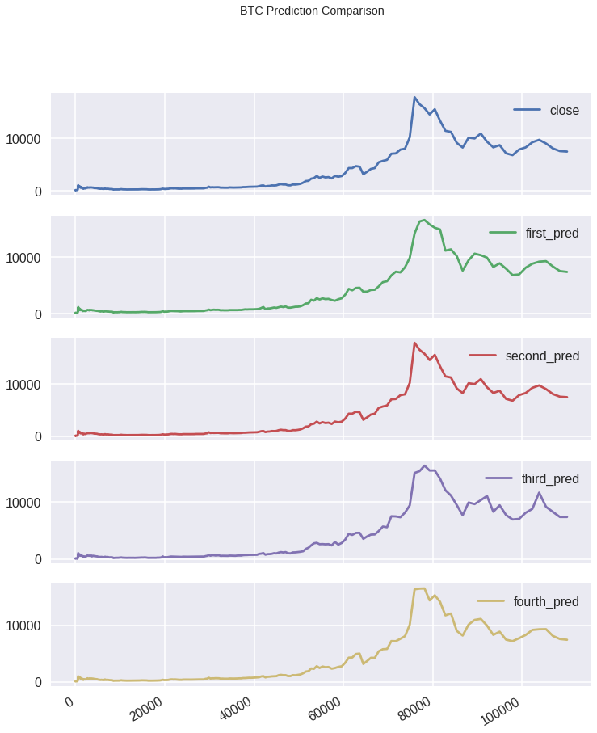

**Figure 43: BTC Prediction Comparison**

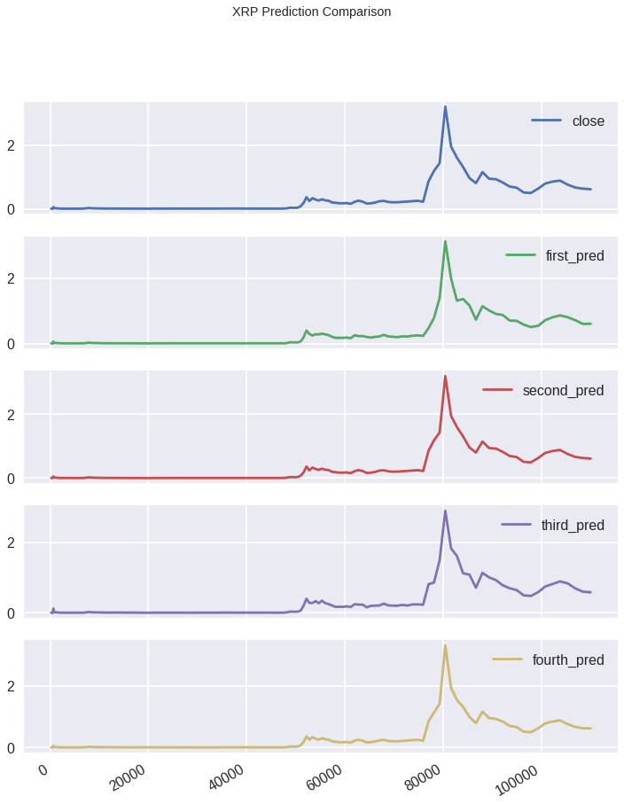

**Figure 44: XRP Prediction Comparison**

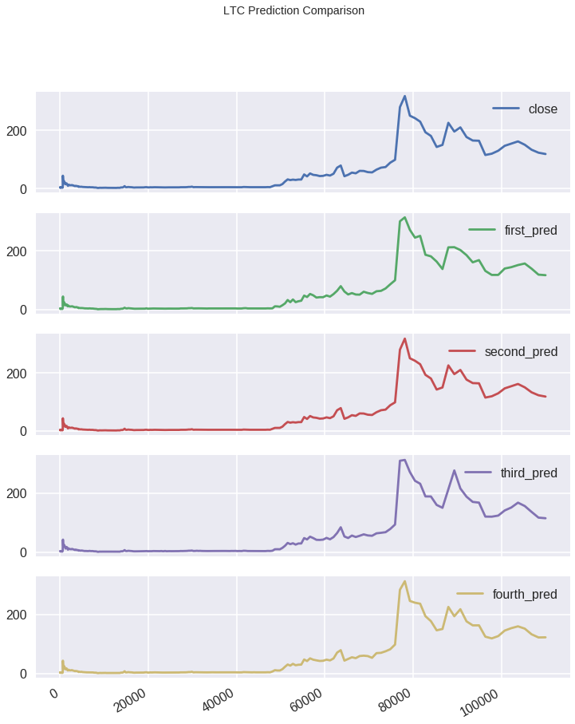

**Figure 45: LTC Prediction Comparison**

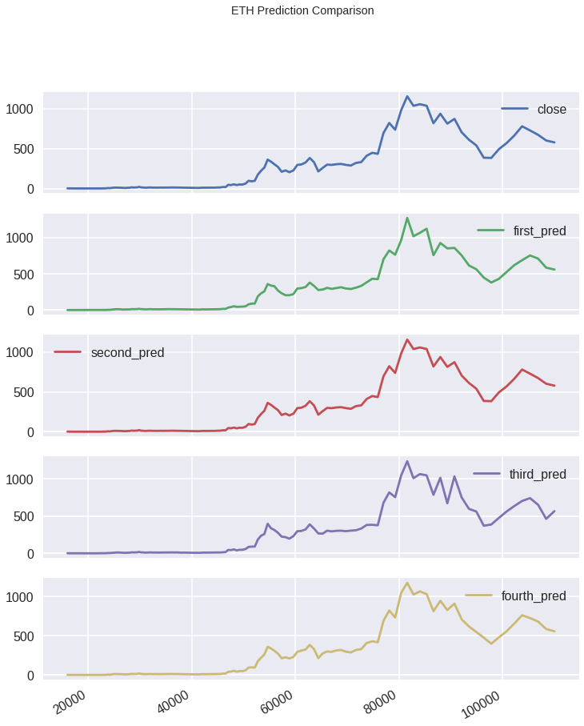

**Figure 46: LTC Prediction Comparison**

Through additional refinement of the models and our research indicating that herding doesn’t exist amongst the largest cryptocurrencies, we ran additional predictions that did not include the sentiment of investors. In running through these models, we determined that while sentiment plays a role across all cryptocurrencies, they did not directly affect the prediction of the four cryptocurrencies that we chose to explore. The behavior of our investors seemed to have a higher impact on the cryptocurrencies that were relatively new in the market. The predictions without the details of the sentiment of our behaviors can be seen in the figures below.

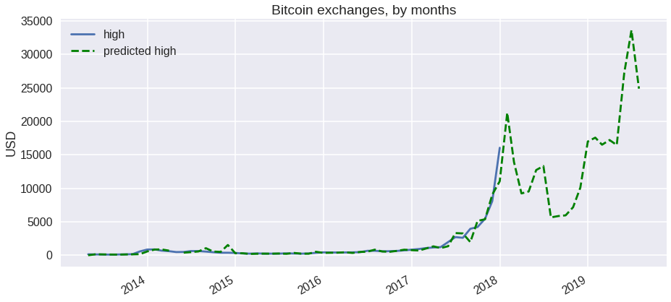

**Figure 47: BTC Prediction Comparison**

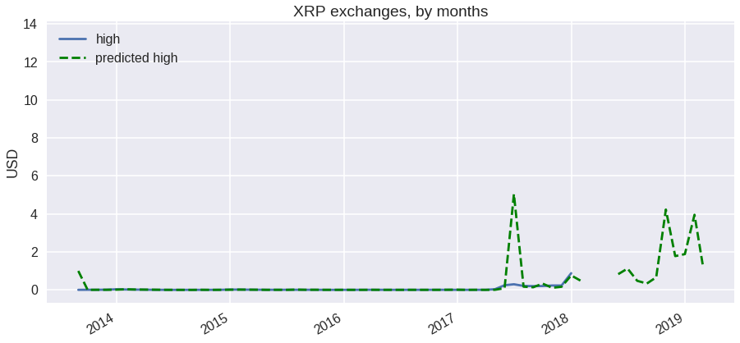

**Figure 48: XRP Prediction Comparison**

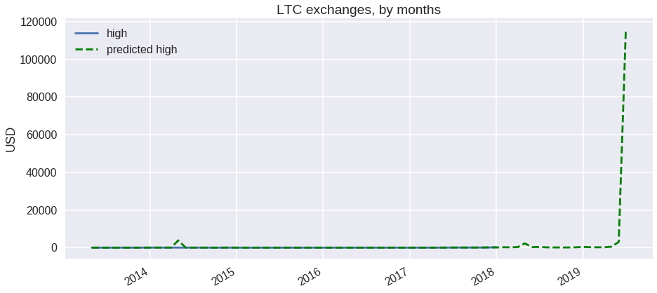

**Figure 49: LTC Prediction Comparison**

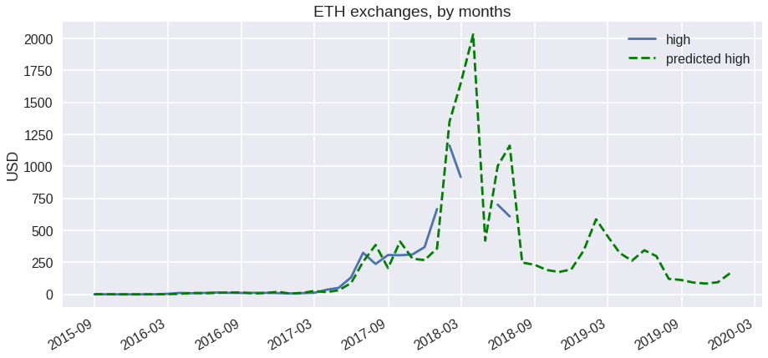

**Figure 50: ETH Prediction Comparison**

1. Conclusion

With the trends and data above, our analysis examined herding behaviors in four of the largest cryptocurrencies with CSSD, CASD, and modified CASD methods. Results suggest that returns of all four cryptocurrencies can be explained by rational asset pricing models. This contradicts results from previous studies. One possible explanation is that previous studies utilize a more comprehensive data and herding behaviors mostly exist in small cryptocurrencies.

This study tests herding behavior in returns of cryptocurrencies. Based on a dataset of Bitcoin, Litecoin, Ethereum, and XRP, this study finds out that herding behavior is not a factor for the returns. Contract to many previous studies, rational asset pricing models can explain the returns. One possible reason is that this study focuses only on four of the largest cryptocurrencies and smaller cryptocurrencies are herding with the larger ones. Therefore, there is no herding behavior among these four largest cryptocurrencies.

Having investigated various data points about currency to determine the relevant points such as ROI. Using our classifier and providing it with data to test against, we refined our models until we find one that can reproduce the same results that we currently expect and see from our analysis in the figures above. With that model, we created a prediction whether a cryptocurrency is trending towards being an investment with more volatility or towards a currency with less volatility. Running the analysis through several different cryptocurrencies that are in existence, we see that the overall trend for cryptocurrencies remains to be volatile for the big cryptocurrencies that have current market share. The lesser known cryptocurrencies didn’t seem to have as much fluctuation than the more historical cryptocurrencies. Being able to see this analysis has helped us to see the potential cryptocurrency stability in the future. As of now, the cryptocurrencies do not seem to be trending towards a viable means for everyday use as a currency. Their current predictions show them to move towards a direction where investors could potentially see a profitable gain in the future.

1. Bibliography

Barberis, Nicholas, Abhiroop Mukherjee, and Baolian Wang. "Prospect theory and stock returns: An empirical test." *The Review of Financial Studies* 29, no. 11 (2016): 3068-3107.

Chiang, Thomas C., and Dazhi Zheng. "An empirical analysis of herd behavior in global stock markets." *Journal of Banking & Finance* 34, no. 8 (2010): 1911-1921.

Corbet, Shaen, Andrew Meegan, Charles Larkin, Brian Lucey, and Larisa Yarovaya. "Exploring the dynamic relationships between cryptocurrencies and other financial assets." *Economics Letters* 165 (2018): 28-34.

"Cryptocurrency Market Capitalizations | CoinMarketCap." Cryptocurrency Market Capitalizations | CoinMarketCap. Accessed October 14, 2018. <https://coinmarketcap.com/>.

ElBahrawy, Abeer, Laura Alessandretti, Anne Kandler, Romualdo Pastor-Satorras, and Andrea Baronchelli. "Evolutionary dynamics of the cryptocurrency market." *Royal Society open science* 4, no. 11 (2017): 170623.

Hyndman, Rob J., and Yeasmin Khandakar. *Automatic time series for forecasting: the forecast package for R*. No. 6/07. Monash University, Department of Econometrics and Business Statistics, 2007.

Vidal-Tomás, David, Ana M. Ibáñez, and José E. Farinós. "Herding in the cryptocurrency market: CSSD and CSAD approaches." *Finance Research Letters* (2018).

Zhang, Wenlang, and Willi Semmler. "Prospect theory for stock markets: Empirical evidence with time-series data." *Journal of Economic Behavior & Organization* 72, no. 3 (2009): 835-849.

1. "Cryptocurrency Market Capitalizations | CoinMarketCap." Cryptocurrency Market Capitalizations | CoinMarketCap. Accessed October 14, 2018. https://coinmarketcap.com/.
2. Shaen Corbet, Andrew Meegan, Charles Larkin, Brian Lucey, and Larisa Yarovaya. 2018. "Exploring the dynamic relationships between cryptocurrencies and other financial assets." Economics Letters 165 (2018): 28-34.
3. Ibid.
4. Shaen Corbet, Andrew Meegan, Charles Larkin, Brian Lucey, and Larisa Yarovaya. 2018. "Exploring the dynamic relationships between cryptocurrencies and other financial assets." Economics Letters 165 (2018): 28-34.